**E-Diary**

1.Who your users are？ 2

2. What are the contents ? 2

2.1 scene? 2

2.2why would they use your app? 2

3. what are the contexts? 2

3.1what is the goal of using this app? 2

3.2what are the problems it solves? 2

3.3Scenarious 3

3.3.1Scenariou1 3

3.3.2Scenariou2 3

4.User case diagram……………...……………………………………………………………4

4.1 adult case………………………………………………………………………..4

4.2 child case………………………………………………………………………..5

**1.Who your users are？**

The people who keep a habit of writing diary and always review their own diary.They don’t have a way to remove the problems of  traditional diaries. At the same time they want to change the way of writing into a electronic means.

1. **What are the contents ?**

**2.1 scene?**

Whether for students in adolescent or white-collar who has to work busy , there exist a lot of thoughts and feelings they would like to express. In this process, many people choose to keep a diary in this way. The diary is not only a window for them to show their inner feelings. But also the training of notes habits, good way to review knowledge as well as analysis events.

**2.2why would they use your app?**

This is a good records of their lives. Our app is convenient to use.Even people don’t take a pen around them.They can still write the diary everywhere on their mobile phone.

1. **what are the contexts?**

**3.1what is the goal of using this app?**

It helps someone who in a diary completed their own electronic diaries.let them keep a good mood in writing process.

**3.2what are the problems it solves?**

He solved writing places limited, time limitation problem in the original diary. It overcomes the problems including depreciation、damage、 lost、 difficulties in retrieval at the same time.

**3.3Scenarious**

**3.3.1Scenariou1**

The first scene we define it as a middle school students staying at home with completing his homework.He open the electronic notebook and begins to record his life in the day time.He writes done what he learned on courses as well as the word a beautiful girl told him.

**3.3.2Scenariou2**

The second scene is for a white-collar already be workers, he abandoned in the company today.Since he is still single,there is no effective way to vent his emotions. So he was lying in bed after dinner, opened the electronic notebook to write down what happened today. His goal is to Ridicule end of this society.

1. **User case diagram**

4.1.1 children login

|  |  |  |
| --- | --- | --- |
| **UseCase** | Children login | Use case type& business requirements |
| **ID** | C001 |
| **Main member** | Children | |
| **Other members** | Log in system | |
| **Related person** | User: care for their own use of landing process simple and friendly enough. Development team: concerned about the difficulty of the implementation is controllable, multi-user concurrent operation will not be unexpected problems. | |
| **introduce** | This use case introduce the log in。 | |
| **precondition** | Children want to write diary on APP | |
| **postcondition** | Children can write the diary or try again。 | |
| **describe** | **User** | **APP** |
| 1.1 User open the APP  1.2 User put the password and usename。  1.3 User point log in | If right--log in  Wrong--try again |

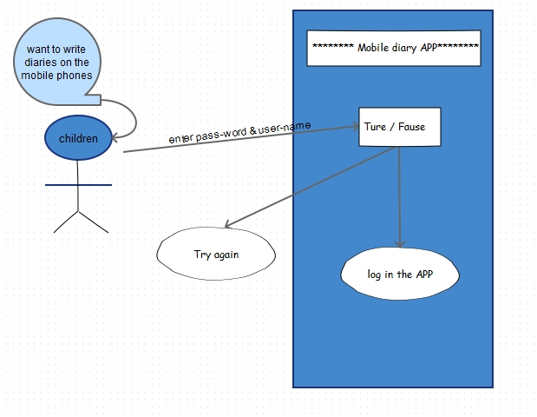

* + 1. children write diary

|  |  |  |
| --- | --- | --- |
| **UseCase** | Children write diary | Use case type& business requirements |
| **ID** | C002 |
| **Main member** | Children | |
| **Other members** | Children write diary | |
| **Related person** | User: care for their own use of write diary simple and friendly enough. Development team: concerned about the difficulty of the implementation is controllable, multi-user concurrent operation will not be unexpected problems. | |
| **introduce** | This use case introduce the Children write diary system。 | |
| **precondition** | Children have already log in the APP | |
| **postcondition** | Children can write diary and save it。 | |
| **describe** | **User** | **APP** |
| 1.1 User creat a new diary  1.2 User write the new diary。  1.3 User save or unsave the diary | Creat and save the app or delete the project |

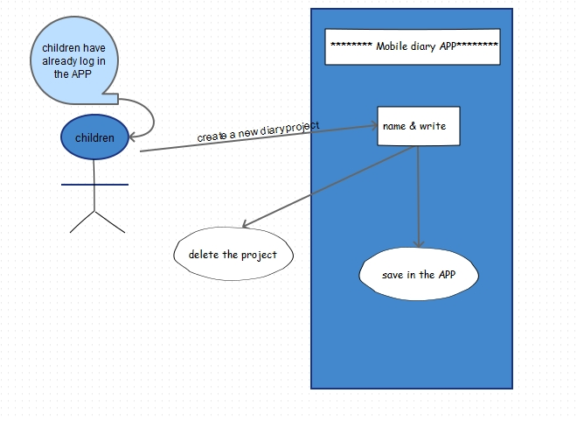

* + 1. children manage diary

|  |  |  |
| --- | --- | --- |
| **UseCase** | Children mangment diary | Use case type& business requirements |
| **ID** | C003 |
| **Main member** | Children | |
| **Other members** | mangment system | |
| **Related person** | User: care for their own use of mangment system simple and friendly enough. Development team: concerned about the difficulty of the implementation is controllable, multi-user concurrent operation will not be unexpected problems. | |
| **introduce** | This use case introduce mangment system。 | |
| **precondition** | Children want to write diary on APP | |
| **postcondition** | Children can delet / modify / share the diary。 | |
| **describe** | **User** | **APP** |
| 1.1 User open the APP  1.2 User delet the diary  1.3 User share the diary  1.4 User modify the diary | Program delet / modify / share the diary |

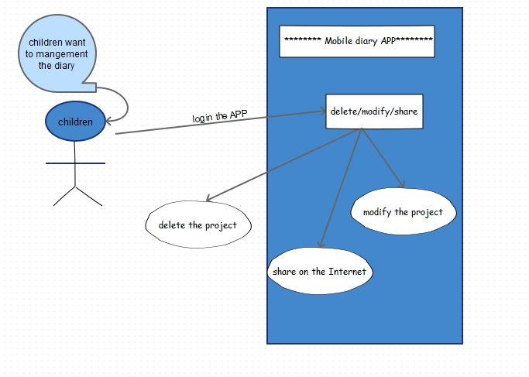

4.2.1 Adult login

|  |  |  |
| --- | --- | --- |
| **UseCase** | Adult login | Use case type& business requirements |
| **ID** | H001 |
| **Main member** | Adult | |
| **Other members** | Log in system | |
| **Related person** | User: care for their own use of landing process simple and friendly enough. Development team: concerned about the difficulty of the implementation is controllable, multi-user concurrent operation will not be unexpected problems. | |
| **introduce** | This use case introduce the log in。 | |
| **precondition** | Adult want to write diary on APP | |
| **postcondition** | Adult can write the diary or try again。 | |
| **describe** | **User** | **APP** |
| 1.1 User open the APP  1.2 User put the password and usename。  1.3 User point log in | If right--log in  Wrong--try again |

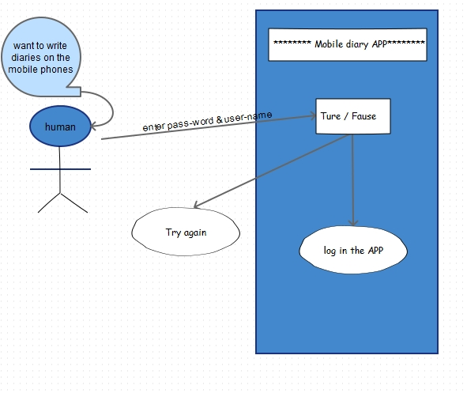

4.2.2 Adult write diary

|  |  |  |
| --- | --- | --- |
| **UseCase** | Adult write diary | Use case type& business requirements |
| **ID** | H002 |
| **Main member** | Adult | |
| **Other members** | Adult write diary | |
| **Related person** | User: care for their own use of write diary simple and friendly enough. Development team: concerned about the difficulty of the implementation is controllable, multi-user concurrent operation will not be unexpected problems. | |
| **introduce** | This use case introduce the human write diary system。 | |
| **precondition** | Adult have already log in the APP | |
| **postcondition** | Adult can write diary and save it。 | |
| **describe** | **User** | **APP** |
| 1.1 User creat a new diary  1.2 User write the new diary。  1.3 User save or unsave the diary | Creat and save the app or delete the project |

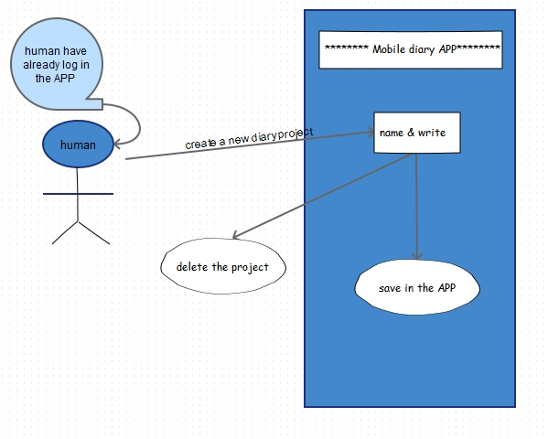

4.2.3 Adult manage diary

|  |  |  |
| --- | --- | --- |
| **UseCase** | Adult mangment diary | Use case type& business requirements |
| **ID** | H003 |
| **Main member** | Adult | |
| **Other members** | mangment system | |
| **Related person** | User: care for their own use of mangment system simple and friendly enough. Development team: concerned about the difficulty of the implementation is controllable, multi-user concurrent operation will not be unexpected problems. | |
| **introduce** | This use case introduce mangment system。 | |
| **precondition** | Adult want to write diary on APP | |
| **postcondition** | Adult can delet / modify / share the diary。 | |
| **describe** | **User** | **APP** |
| 1.1 User open the APP  1.2 User delet the diary  1.3 User share the diary  1.4 User modify the diary | Program delet / modify / share the diary |

